 **EXAMINATION**

☐ 23 ☐36 ☐10990

☐82205 ☐82210

☐Not after care

DATE: _________________ PATIENT NAME: _________________________ D.O.B: _____________

BLOOD PRESSURE: ______________ BLOOD SUGAR LEVEL: _________________

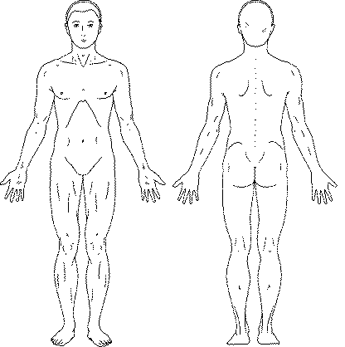 **SUSPICIOUS LESIONS**

1.

2.

3.

4.

5.

☐ Dysplastic naevus

☐ Solar Keratoses

☐ Cryotherapy

☐ Seborrhoeic Keratoses

☐ Solar Lentigo

☐ NO SUSPICIOUS LESIONS

☐ Mx - BIOPSY / EXCISE - TODAY / REBOOK

☐ Sunsmart advice

☐ Regular Review

Review in ____ months/_____ year

Dr Robin Goh

Provider No: 4661412K



**QUESTIONNAIRE**

NAME: ________________________________ DOB: _________________

Have you had MELANOMA before? YES / NO

Have you had other skin cancer (e.g. Basal Cell/Squamous Cell cancer) before? YES / NO

Do you have any skin lesion that you are concerned about? YES / NO

If yes, where? __________________________________________________________________

Has it changed? YES / NO If yes, please describe (e.g. darker, larger, changed shape, itch). ______________________________________

Is there a family history of Skin cancer? YES/NO

If YES, do you know what type? Melanoma or Non Melanoma

MEDICAL HISTORY AND MEDICATIONS:

Do you have diabetes? YES / NO

Do you have heart disease? YES / NO

Please state other medical conditions if relevant _______________________________________

Do you take medications to thin your blood? YES / NO

If yes, which one (eg. aspirin, warfarin etc.) ____________________________________

Please list other medications if relevant: ______________________________________________

Please state any allergies if present: __________________________________________________

Patient’s Signature: ____________________________ Date: _________________